rafs pods and layout dataset

2019.7.10 V1.0 [hli@hanningzn.com](mailto:hli@hanningzn.com)

1. Layout

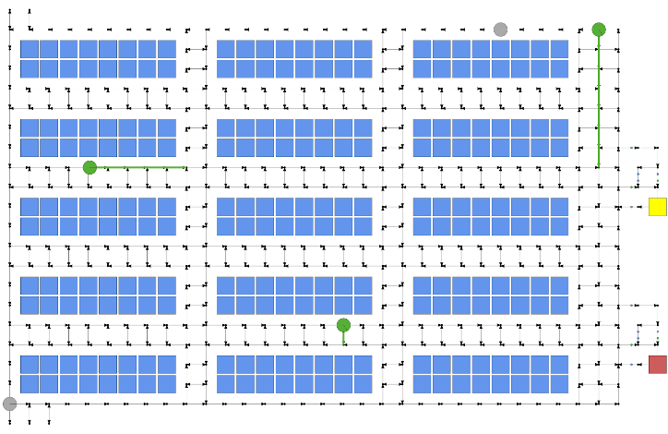

Fig: layout for this dataset.

Layout file:

* \rafs dataset\layout\1-1-1-5-240.xinst
* \rafs dataset\layout\1-1-1-2-1.xlayo

→ Pods position, Robot beginning position, Stations position, Waypoint etc.

→

* 1 X tier
* 1 X pick station east (red rect)
* 1 X replenishment station east (yellow rect)
* 5 X robots
* 240 X pods

2. Fixed order

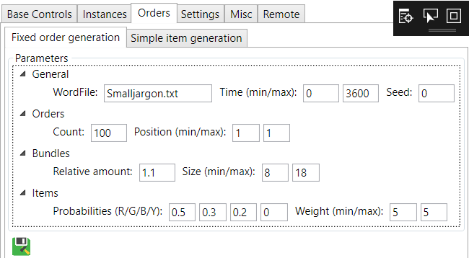

Fig: about the parameter settings in RawSim

We use the same parameter, but only set different count of order list, about 20, 50, 100.

* Order 20: \rafs dataset\orders and bundles\Letter-18-7-20-3449.03.xitem
* Order 50: \rafs dataset\orders and bundles\Letter-18-16-50-3453.93.xitem
* Order 100: \rafs dataset\orders and bundles\Letter-18-34-100-3518.56.xitem

In file, you will see the information:

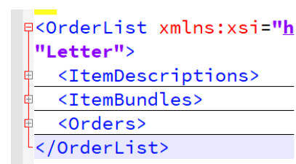

About the ItemDescription:

<ItemDescription ID="0" Type="Letter" Weight="5" Letter="114" Color="Blue" />

* There are three colors: Red, Green, Blue
* Letter="114" means the character in ascii table →  r

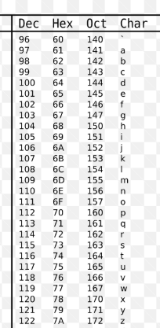

About  <ItemBundles> and  <Order>:

* It means the input(item bundles) information and output(orders) information.

3. Pods information

The initial items information in the pods:

* \rafs dataset\pods\pods_infos.txt
* \rafs dataset\pods\pods_items.txt

In pods_items.txt:

184;1.50/19.50;red/r/12;blue/i/6;blue/u/6;green/u/6;red/u/6;green/a/12;blue/m/6;green/m/6;red/m/18;red/s/6;

* 184 means pod number.
* 1.50/19.50 means the pod position, X: 1.50, Y: 19.50, origin of coordinate is in the bottom left corner.
* blue/u/6 means there are 6 pieces for the item “character ‘u’ with blue color”.